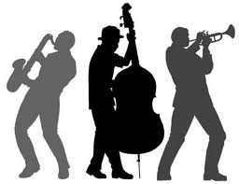
St Ambrose High School

Jazz

Working towards National 4/5
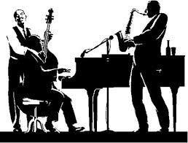

Name:

Class:

Teacher:

A.S 1.1, 1.2, 1.3
Learning Intention
I will be able to identify Jazz styles and the features and instruments present in each.
Success Criteria
I can identify the differences between each style.
I can identify the distinctive instruments present in each style.
Jazz Music Styles

Jazz is a term used to describe many different styles of music. The styles we will focus on in this unit are Blues, Ragtime, Swing & Gospel.

Before we learn these, it is important to know and understand the background of the music that we studied, why it was written, what was going on in society around about the music. These are known as the Social and Cultural influences on the music.

Jazz music has a very important background to the music. Your teacher will set you an assignment to research the important history of this musical style.
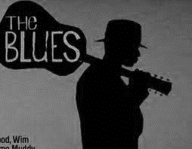

BLUES

The Blues is a musical style that began around ____________________________.

Blues songs were sung by____________________________.

These songs evolved from work songs, folk music and songs that were sung many years earlier by slaves working on cotton plantations. These songs were known as _____________.

This rich history of Blues music means that Blues songs tend to focus on storytelling and describing the tales of life for these people. As such, people tend to think of Blues as being sad songs, although this is not always the case, especially as Blues evolved through the 20th century.

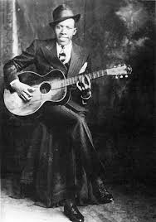
There are two important musical features of Blues you need
to know about:

A specific chord structure known as _________________________

A specific type of scale known as____________________________.

The Blues Scale

Most Blues music (and other forms of Jazz too) uses notes from the Blues Scale.

In the key of C, the Blues scale would have the following notes…

Now play this scale on the keyboard

12 Bar Blues

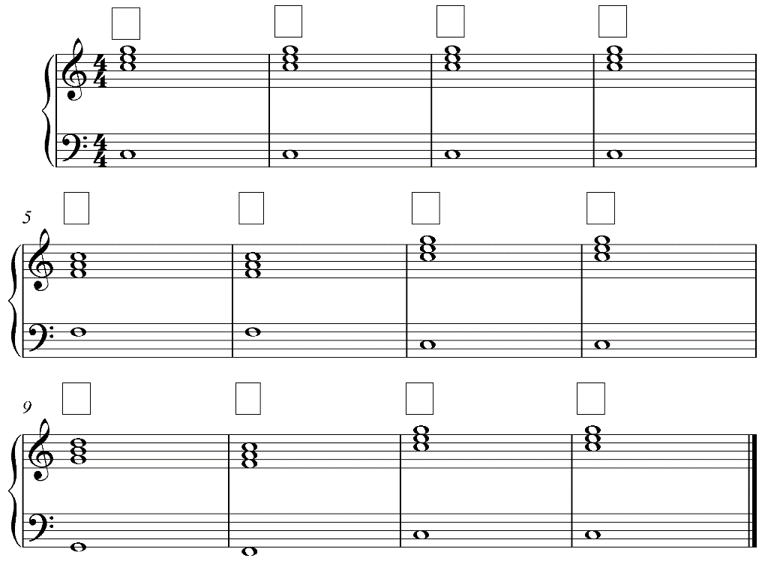

Write the chord names in the boxes – the lowest note in the treble clef will be the name of the chord!

Or – just read the bass clef note!

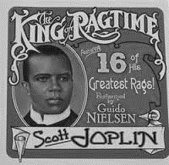
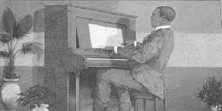
RAGTIME

Ragtime was a style of Jazz which originated in the

was one of the most famous ragtime composers and performers and was even given the nickname “The King of Ragtime”.

The music was almost always written for

Ragtime music features a strongly melody in the right hand

The left hand will have an accompaniment known as a

The melody often has lots of runs.

Important Ragtime Concepts:
Syncopation

Vamp

Chromatic | These three concepts are very important in Ragtime, but can be found in other styles too.

The excerpt of music you have just heard also contains another important concept – an anacrusis. This is a concept that can be found in any style or period, not just Jazz.
Anacrusis

An excerpt of ‘The Entertainer’ by Scott Joplin. Clearly label Syncopation, Chromaticism and Vamp.

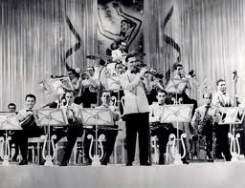
SWING

A Jazz style developed in the__________.

Swing is played by a ____________________ that provided music to___________________.

Swing bands usually featured _____________who would ________________ on the melody over the arrangement.

Famous Big Band Leaders include___________________________________________________________.

Swing music is usually played in medium to fast tempos - _______________________________________

The main rhythmic feature is the ‘swinging’ of the quavers, producing a "lilting" feel. Usually the drums would play this groove pictured.

Instruments in a typical Swing Band
Rhythm section
Swing music uses a strong rhythm section of

Lead section
Brass instruments -

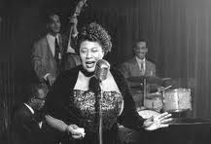
Woodwind instruments -

Vocalists - or

Scat Singing is often heard in Swing music.

Scat singing is found in swing music and many other styles of Jazz.
Name some famous Jazz singers

Walking Bass

Swing and other Jazz music often has a Walking Bass

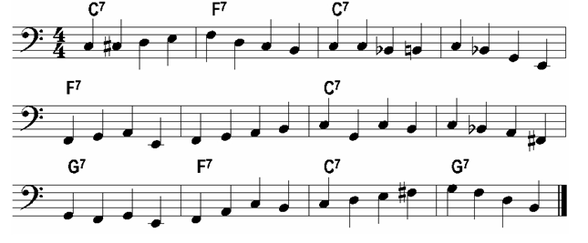

Improvisation

Improvisation is a major part of most styles of Jazz, including Swing.

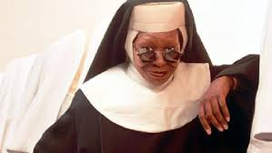
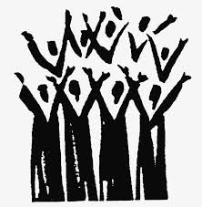

GOSPEL

KNOWLEDGE CHECK
Tick one box from column A and column B
Question 1 Question 2

A - Style B - Features
A – Style B – Features

Ragtime 12 Bar Blues
Blues Scat Singing
Swing Improvisation
Gospel Syncopation

Ragtime 12 Bar Blues
Blues Scat Singing Swing Improvisation
Gospel Syncopation
2
2

Question 3
A - Style B - Features

Ragtime 12 Bar Blues
Blues Scat Singing
Swing Improvisation
Gospel Syncopation

2

Question 4
Name the style of music and give a reason to support your answer.
1

Question 5
Name the style of music and give a reason to support your answer.
1

Question 6
Improvising is when
1

Question 7
Scat singing is when
1

Question 8
Name as many instruments as you can in the following excerpt.
7

Question 9
Write the letter names in for the Blues Scale below.

7

Literacy Question

You now have to answer questions relating to the music printed below.
Listen to the excerpt and follow the music.

Do not attempt to write during the first hearing.

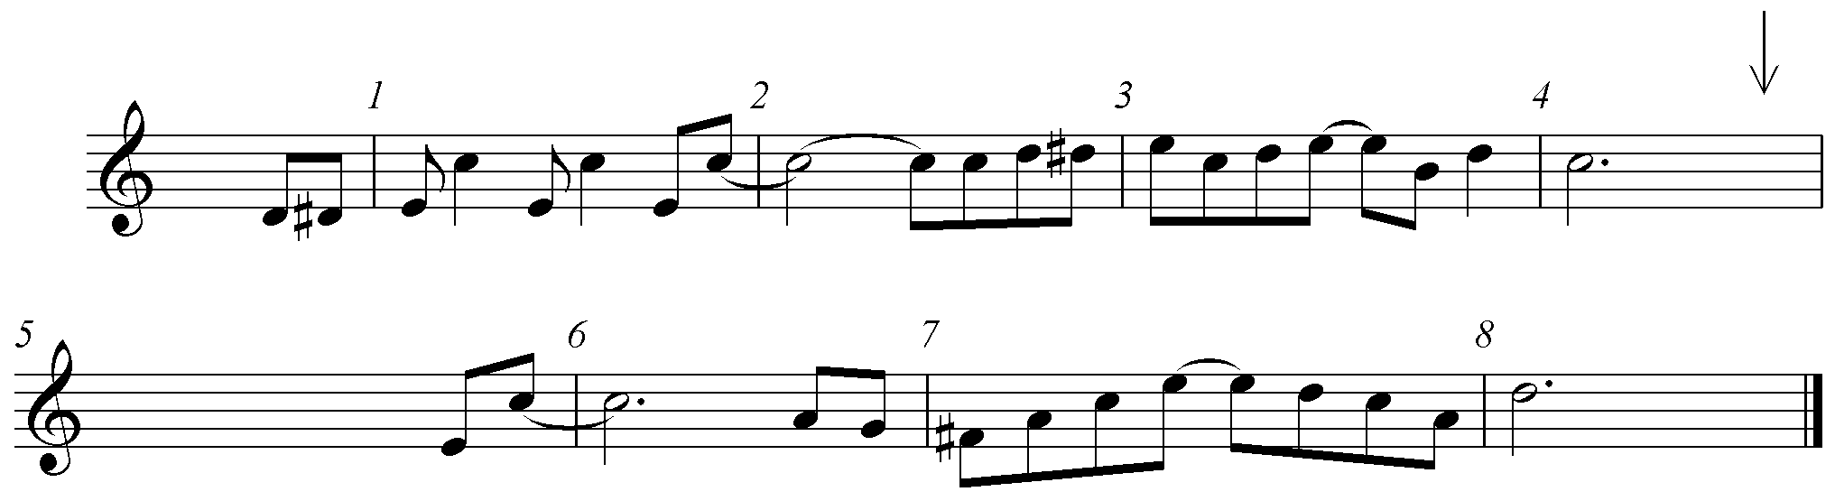
You will hear the music 3 times.

- There is an upbeat into this piece, what is the correct musical term for this? ______________________________.
1

1
- Insert the time signature at the correct place in the music.

- Insert a bracket over three notes beside each other that move in semitones/chromatic scale.
1
1
- The tied notes create a distinctive rhythmic effect called_____________________

- The interval between the first two notes in bar 1 is a_______________
1

- Complete the missing notes from the last beat in bar 4 to bar 6.
6

Total /35

