

**Music Technology**

***Higher***

***Controls / Processes / Effects***

Name:......................................Class:.......................................

Teacher: ……………………..…Date Started:………………...…

***(Higher 2.2)***

***All definitions found in multi-level definitions dictionary – Higher folder***

***Controls/Processes and Effects***

***ADSR***

**ADSR stands for Attack, Decay, Sustain, Release**

**One way ADSR envelopes are used is shaping sounds in things like synths.**

* **Attack is what happens when a sound begins**
* **Decay is what happens to the sound after the attack phase is complete.**
* **Sustain is the level at which the sound stays until the note is stopped**
* **Release is what happens when the sound stops (opposite of attack).**
* 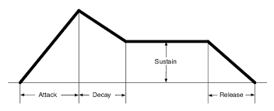

**In the diagram above, the sound looks like it will fade in (slow attack) then reduce in volume (decay), maintain a volume level (sustain) and when the sound stops it will fade out (release). These are all measured in seconds. (aka Attack:1.2s)**

***Autotune***

**Autotune can be used correctively or creatively.**

**When being used correctively, it should be difficult to hear that it is even being used. For example, someone sings or plays slightly out of tune and the engineer wants to rectify this using an autotune plugin. Here, the attack of the autotune would be set to slow so that the changes in tuning aren’t as noticeable.**

**When used creatively as an effect, the attack would be set much quicker, so that the voice or instrument sounds almost robotic. Listen to Cher – Believe, Daft Punk – Digital Love.**

***Crossfade***

**Crossfading is fading one piece of audio out whilst at the same time fading another piece of audio in. There are 2 reasons to crossfade.**

1. **A DJ will crossfade two songs so that they seem to merge. If using an app such as Spotify, you can set your music to crossfade so that there is never a gap between tracks. A good DJ will beatmatch the different tracks so that not only do they crossfade, but they also stay at the same tempo and maintain the same beat. You can’t do this in Spotify ☹**
2. **You might crossfade 2 pieces of audio in a project when creating a loop to eliminate pops or clicks.**

***De-esser***

**This is primarily used on vocal tracks.**

**Think of a De-esser as an automatic LPF (low pass filter). The de-esser senses when really high frequency noises are present in the recording (think of an ‘sssssss’ sound).**

**These frequencies can be a bit harsh, but they don’t happen all the time. So the de-esser will listen for these frequencies, and when detected, it will apply the appropriate amount of LPF (reduce the very high frequencies).**

**Put another way, a de-esser takes out really high, offensive frequencies only when they happen.**

***Filter / Cut-off frequency***

**Filters have 2 properties. Cut-off and Resonance.**

**A filter can be applied to an entire track, or to a single track and everything in between.**

**Think of a filter as a LPF or a HPF. When you adjust the frequency of the filter, this is known as the cut-off frequency.**

**If you add resonance to your filter, it will make a phaser-type sound when the filter is opening and closing.**

***Threshold***

**Threshold is a term used in many many different applications in music technology. Thankfully it always means the same thing.**

**Threshold is the point at which something starts to work.**

**Example – in a noise gate, the noise gate only works when the sound reaches a certain volume – or threshold. This is also true of compressors, de-essers, etc.**

***Vocoder***

**Certain synths and keyboards have a vocoder built into them. The keyboard will have a microphone plugged directly in to it.**

**When in ‘vocoder mode’ the player will press a key and then speak into the mic. The keyboard will then ‘merge’ the voice and the synthesiser. Listen to Mr Blue Sky at 2m22s.**

***Phaser***

**A phaser is an effect which, when applied gives a ‘swishy’ type of sound. Popular in funk, but in many other genres, a phaser is basically a 1 band EQ which moves up and down the frequency spectrum. So you could essentially make your own phaser by putting a lot of automation onto an EQ plugin.**

**Two important controls in a phaser are;**

1. **Depth. This controls how intense the ‘swishy’ sound is.**
2. **Rate/Speed. This controls how fast or slow the ‘swish’ happens**

**Apply a phaser to one of your tracks and spend time adjusting the depth and rate/speed.**

***Flanger***

**A flanger sounds similar to a phaser. It uses the same basic premise as a chorus effect, but with a shorter delay.**

***Graphic EQ***

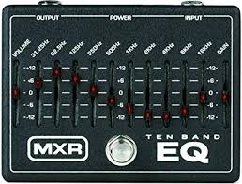

**As you’ll see from the picture, a graphic EQ is one where you can adjust fixed frequencies amplitude. The graphic EQ in the picture is a 10 band eq but you can get a different amount of bands depending on the hardware . This means that there are 10 different frequencies you can adjust.**

***Parametric EQ***

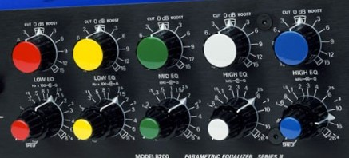

**The difference between this and the graphic EQ is that in a parametric EQ, you can adjust the frequency of each band whereas with the graphic EQ, you cannot adjust the frequencies. Just like the graphic EQ, you can have a 10 band parametric EQ, or a 3 band, etc. The one in the picture is a 5 band EQ. The top row of rotary controls adjust the amplitude and the bottom row adjusts the frequency of each band.**

***Q (bandwidth)***

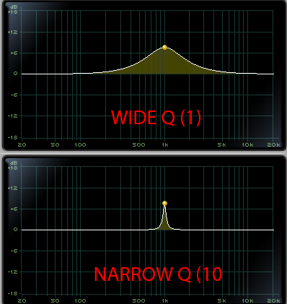

**Q adds a third dimension to an EQ. With a parametric EQ, have the ability to adjust amplitude, frequency and we can also add in a ‘Q’ control.**

**Q adjusts how wide or narrow a bandwith you’re adjusting.**

**The picture here shows a wide Q setting at the top and a Narrow Q setting at the bottom.**

***Shelving EQ***

**Shelfing is a method of using an EQ. Shelfing is where you boost (or more commonly) cut all frequencies above or below a certain point.**

**So for example in a vocal recording we know that our voices tend not to produce any useful noises below 100hz. Rather than leave these frequencies in our mix, we would cut everything below around 100hz. To do this we use a shelfing EQ. It looks like this:**

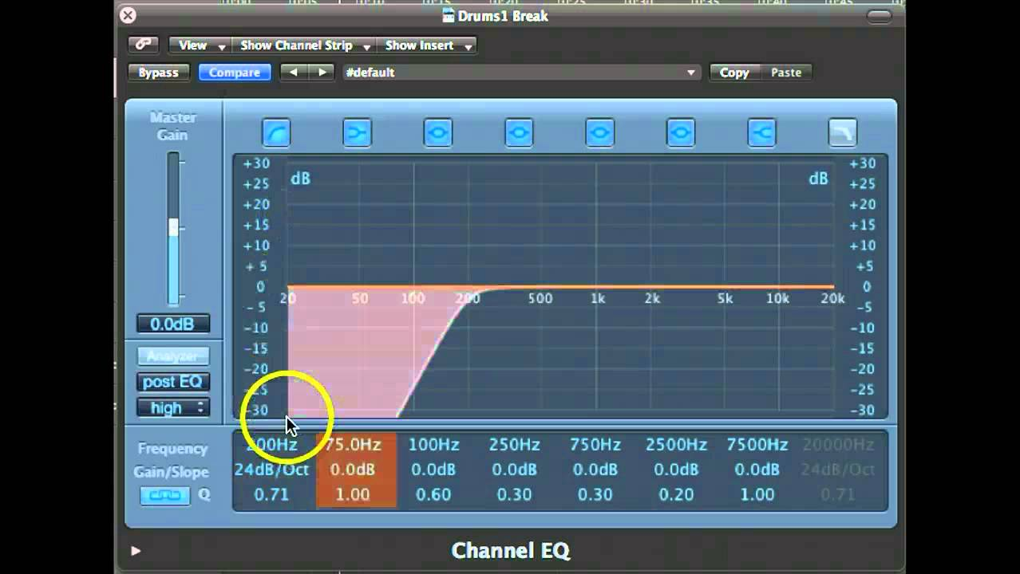

***Harmoniser***

**If a performer plays a single note through a harmoniser, a chord is heard.**

**The harmoniser would be set to a particular key/mode and the performer would play a single melody line. As a result, the melody would be harmonised according to the set key/mode.**

***LPF / HPF***

**LPF – Low Pass Filter**

**HPF – High Pass Filter**

**A method of using an EQ using a shelfing technique. If you apply a LPF, you basically attenuate (cut out) high frequencies. If you apply a HPF, you attenuate low frequencies. A way to remember it is, LPF, allows the LOWS to PASS through. HPF, allows the HIGHS to PASS through.**

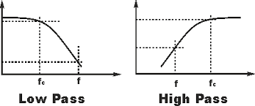

***Pitch Shift***

**Pitch shifting where you change the pitch of an individual track or indeed an entire project.**

**Pitch shifting is usually measured in 2 ways. When changing the pitch in small increments, we move it up or down a certain number of ‘Cents’. If changing it in larger intervals, we refer to changing it in ‘semi-tones’.**

**Autotune plugins share the same type of technology as pitch shift plugins.**

***Portamento/Glide***

**Portamento is something which is used on synths. Both hardware synths and software synths.**

**If playing the note C for example on a synth and then playing the note C an octave above, portamento (When added) will make the note slide from the low C to the high C. How much portamento determines how long the slide takes.**

***Pre-fade / Post-fade***

**This refers to the signal chain.**

**Pre-fader is where plugins or busses are inserted in the chain BEFORE the signal is processed through the fader.**

**Post-fader is where plugins or busses are inserted in the chain AFTER the signal is processed after the fader.**

***Time compression/expansion***

**This is a way of speeding up (compression) or slowing down (expansion) a piece of audio without altering the pitch. Go to a youtube app and tap the … at the top right. Change the playback speed and you will hear how time compression and expansion sound.**

***Tremolo***

**Tremolo is a modulation effect which causes the volume of a signal to alternate up and down. In a tremolo you can control the depth and rate of the volume change.**

***Vibrato***

**Vibrato is an effect which changes the pitch of a sound in a similar way to a LFO. In vibrato you can control the rate and depth of the pitch change.**

***Microphone and Placement***

These will be covered in a separate booklet